Project: AI Resume Optimizer & Interview Assistant
What You'll Learn
Python | Streamlit
- Project Structure  - Modules  - Packages  - OOP  - Functions  - Error Handling  - Logging  - Environment Variables  - File Handling | - Layout  - Sidebar  - File Upload  - Session State  - Multi-page Apps  - Caching

Prompt Engineering | LLM | Production Engineering
- Role Prompting  - Few-shot  - Chain of Thought  - Structured Output  - Prompt Templates  - Prompt Versioning | - Ollama  - Local Models  - Temperature  - Context Window  - Tokens  - Streaming | - Config files  - Constants  - Logging  - Exception Handling  - Utility Modules  - Reusable Code  - Scalability
Learning Roadmap
We will build the project in 20 Modules.
Module 1 Project Planning  Module 2 Project Structure  Module 3 Python Environment  Module 4 Configuration Management  Module 5 Logging System  Module 6 Utility Functions  Module 7 Reading Resume PDF  Module 8 Connecting Ollama  Module 9 Prompt Engineering  Module 10 ATS Resume Analysis | Module 11 Resume Optimizer  Module 12 Interview Question Generator  Module 13 Interview Evaluation  Module 14 Cover Letter Generator  Module 15 Job Description Matching  Module 16 Streamlit UI  Module 17 Conversation Memory  Module 18 History Database  Module 19 Deployment  Module 20 Production Improvements
Learning Style
Every module will contain:
1. Theory Understand the concept.  2. Folder Structure Where every file belongs.  3. Complete Code No missing parts.  4. Line-by-Line Explanation We'll explain every significant line and why it exists.  5. Industry Best Practices How experienced engineers structure and maintain the code. | 6. Debugging Guide Common issues, how to identify them, and how to fix them.  7. Interview Questions Questions a recruiter or interviewer might ask about the topic.  8. Mini Assignment A small task to reinforce what you've learned before moving on.
Project Architecture
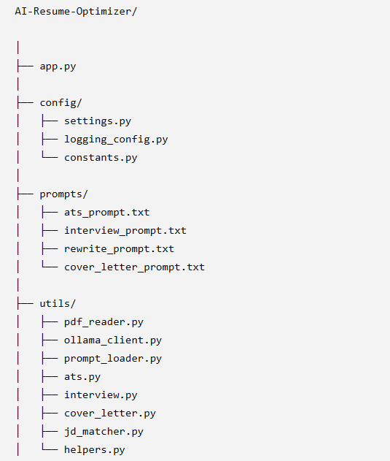
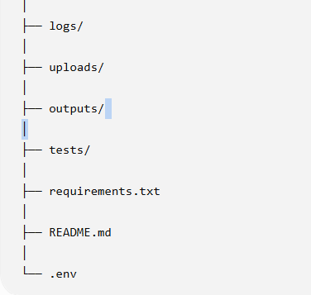
By the End of This Project
You'll be able to explain and demonstrate:
- How LLMs work
- How Ollama serves local models
- How to engineer effective prompts
- How to structure a production-ready Python application
- How to build a Streamlit interface
- How to analyze resumes against job descriptions
- How to generate interview questions and evaluate answers
- How to troubleshoot and improve an AI application
- How to discuss design decisions confidently in interviews
Module 1 — Project Planning & System Design
Goal: Before writing a single line of code, understand what we are building, why we're building it, and how all the pieces fit together.
- What Problem Are We Solving?
Imagine you're a job seeker.
You have:
- A resume
- A job description
You want answers to questions like:
- Is my resume ATS-friendly?
- What skills am I missing?
- How can I improve my resume?
- What interview questions might I be asked?
- Can AI help me prepare for interviews?
Instead of manually checking everything, we'll build an AI assistant that does it automatically.

2. What Will Our Application Do?
Our application will allow users to:
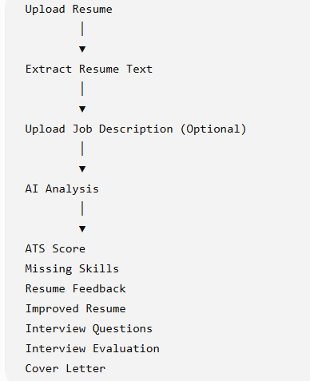

3. High-Level System Flow
User
│
Streamlit UI
│
Resume PDF Reader
│
Extract Resume Text
│
Prompt Engineering
│
Ollama (Llama 3.2)
│
AI Generated Output
│
Display Results

4. Technology Stack
Technology | Why We Use It
Python | Main programming language Industry standard for AI and automation
Streamlit | Easy web application development Without HTML, CSS, or JavaScript, we can quickly build a professional interface.
Ollama | - Run LLMs locally Instead of sending data to cloud APIs, Ollama runs the model locally.  - Advantages: Free , Fast , Private , No API cost , No internet required after model download
Llama 3.2 | AI model for analysis
Prompt Engineering | Guide the AI to produce better outputs The same model can produce very different outputs depending on how you ask it.
PyPDF2 / pdfplumber | Extract text from PDFs
Logging | Track application events and errors
Config Files | Manage settings in one place
Git | Version control

5. Functional Requirements  Our application must be able to:  - Upload a resume  - Read PDF content  - Extract text  - Send prompts to the AI model  - Display analysis  - Suggest improvements  - Generate interview questions  - Evaluate interview answers  - Generate cover letters  - Match resumes to job descriptions | 6. Non-Functional Requirements  These describe how the system should behave.  Requirements Fast Modular Maintainable Scalable Readable Secure Reliable Meaning Quick response time Organized into reusable modules Easy to update Easy to add features Clear code for other developers No hardcoded secrets Handle errors gracefully
7. System Components
We'll divide the application into independent modules.
Each module has a single responsibility, making the code easier to understand and maintain.
UI
↓
PDF Reader
↓
Prompt Loader
↓
Ollama Client
↓
ATS Analyzer
↓
Interview Generator
↓
Cover Letter Generator
↓
Logger
↓
Configuration

8. Clean Architecture
A common mistake beginners make is putting all the code in one file.
❌ Bad approach:
app.py
2000 lines
Problems:
- Hard to debug
- Hard to test
- Hard to reuse
- Difficult for teams to collaborate
✅ Good approach:
app.py
↓
pdf_reader.py
↓
ollama_client.py
↓
ats.py
↓
prompt_loader.py
Benefits:
- Easier to maintain
- Easier to test
- Easier to scale
- Easier for multiple developers to work on different parts

9. Data Flow
This is the core pipeline of our application.
Resume.pdf
↓
Read PDF
↓
Extract Text
↓
Create Prompt
↓
Send to Ollama
↓
Receive AI Response
↓
Display Result

10. Why We Need Modular Programming
Imagine six months from now you want to switch from Llama 3.2 to another model.
If all the code is in one file:
❌ You'll need to change many places.
If the model interaction is isolated:
ollama_client.py
✅ You only update one file.
This reduces bugs and speeds up development.

11. Coding Standards We'll Follow
Throughout this project, we will:
- Use meaningful variable names.
- Write small, focused functions.
- Add type hints where appropriate.
- Document functions with docstrings.
- Avoid duplicate code.
- Handle exceptions properly.
- Keep configuration separate from logic.
- Write code that is easy to read and review.
These practices make the code more professional and easier to maintain.

12. Industry Workflow
The development process we'll follow is:
Plan
↓
Design
↓
Create Folder Structure
↓
Write Code
↓
Test
↓
Debug
↓
Refactor
↓
Deploy

13. Real-World Skills You'll Gain
By completing this project, you'll learn how to:
- Structure a production-ready Python project.
- Build AI-powered applications.
- Design effective prompts for LLMs.
- Organize code using clean architecture.
- Manage configuration and logging.
- Debug and maintain a modular codebase.
- Explain your design choices during interviews.

Interview Questions
- Why is planning important before development?
- What is clean architecture?
- What is modular programming?
- What is the role of Streamlit in this project?
- Why are we using Ollama instead of a cloud API?
- What is the difference between functional and non-functional requirements?
- Why should configuration be separated from application logic?
- What are the benefits of logging in production applications?
Module 2 – Professional Project Setup & Development Environment
Goal: By the end of this module, you will have:
- A professional Python project set up in PyCharm
- A virtual environment
- All required packages installed
- Git initialized
- A clean project structure
- A requirements.txt
- A .gitignore
- A .env
- The project ready for development

Part 1: Install Required Software
1. Python  Install Python 3.11.x.  Verify installation:  python --version  Expected:  Python 3.11.x | 2. PyCharm  Install:  - PyCharm Community Edition (Free)  or  - PyCharm Professional (if you already have it)
3. Git  Install Git.  Verify installation:  git --version  Expected:  git version 2.51.x | 4. Ollama  Download and install Ollama.  Later we'll install:  ollama pull llama3.2

Part 2: Create the Project
Open PyCharm.
New Project
AI-Resume-Optimizer
Project structure:
AI-Resume-Optimizer/

Part 3: Create a Virtual Environment
What is a Virtual Environment?
A virtual environment is an isolated Python environment for a specific project.
Expected:
Project A (folder name)
│
|─ venv
└── Packages

Part 4: Create the Folder Structure  Inside your project, create:  AI-Resume-Optimizer/  │  |─ app.py  |─ config/  |─ prompts/  |─ utils/  |─ uploads/  |─ outputs/  |─ logs/  |─ tests/  |─ assets/  |─ requirements.txt  |─ .gitignore  |─ .env  └── README.md | Part 5: Create requirements.txt  Create a file named:  requirements.txt  Add:  streamlit  ollama  pdfplumber  python-dotenv  pydantic  requests  add all required packages
Part 6: Understanding requirements.txt  Instead of asking:  "What packages did I install?"  We simply run:  pip install -r requirements.txt  This installs all required packages in one command. | Part 7: Create .gitignore  Create:  .gitignore
Part 8: Create .env  Create:  .env  Add:  OLLAMA_MODEL=llama3.2  LOG_LEVEL=INFO  APP_NAME=AI Resume Optimizer  Why?  Instead of hardcoding values:  MODEL = "llama3.2"  We store them in one place so changing the model later is simple. | Part 9: Create README.md  Create:  README.md  Example:  # AI Resume Optimizer  A production-ready AI Resume Optimizer and Interview Assistant built using:  - Python  - Streamlit  - Ollama  - Llama 3.2  - Prompt Engineering  ## Features  - ATS Resume Analysis  - Resume Improvement  - Interview Questions  - Cover Letter Generation  - Job Description Matching  This is the first thing recruiters or collaborators will see when they visit your repository.
Part 10: Initialize Git
Open the terminal in PyCharm.
Run:
git init
Check:
git status
You should see your project files listed as untracked.
Part 11: First Project Run
For now, create a simple app.py to verify everything is working.
Code:
import streamlit as st
st.set_page_config(
page_title="AI Resume Optimizer",
page_icon="📄",
layout="wide")
st.title("🚀 AI Resume Optimizer")
st.write("Project setup completed successfully!")
Run the app:
streamlit run app.py
You should see a browser window with the title and message. As below
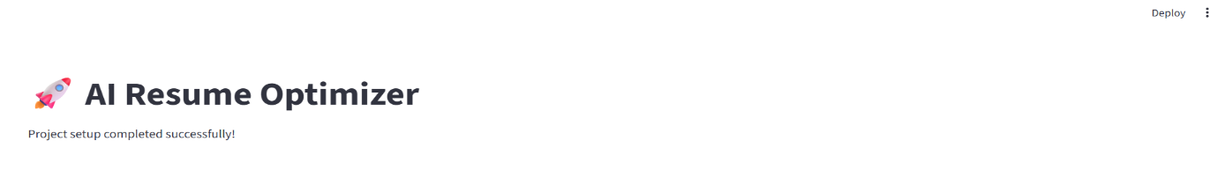

Code Explanation
- import streamlit as st
Imports the Streamlit library and gives it the short alias st.
- st.set_page_config(...)
Sets the page title, icon, and layout. This should be called once at the top of the app.
- st.title(...)
Displays a large heading.
- st.write(...)
Displays text and can also render many other data types.
Interview Questions
- What is a virtual environment, and why is it important?
- What is the purpose of requirements.txt?
- Why do we use a .gitignore file?
- Why should secrets be stored in a .env file?
- What are the advantages of using Git in a software project?
- What does st.set_page_config() do in Streamlit?
- Why is dependency management important in collaborative projects?
Module 3: Professional Configuration Management
Goal: By the end of this module, you will learn:
- What configuration management is
- Why every company uses it
- What is hardcoding
- Why hardcoding is bad
- How to use .env
- How to organize project settings
- How to create reusable configuration modules
- How to load environment variables
- How to access settings anywhere in the project

Part 1: What is Configuration?
Imagine your project has this code.
MODEL = "llama3.2"
Looks fine...
Now imagine after one month you want to use:
llama3.3
Where is it used?
Maybe
- app.py
- ats.py
- interview.py
- cover_letter.py
- helper.py
Now you must search the entire project.
This is called Hardcoding.
What is Hardcoding?
Hardcoding means writing fixed values directly inside the source code.
Why is Hardcoding Bad?
Imagine your company has 25 Python files.
The model name appears in 15 files.
Management says:
"Tomorrow we'll use Mistral instead of Llama."
You now have to update every file.
Problems:
- Time consuming
- Easy to forget one occurrence
- Introduces bugs
- Difficult to maintain
Industry Solution
Store all configurable values in one place.
Instead of:
model = "llama3.2"
Use:
model = settings.MODEL_NAME
Now changing the model requires editing only one file.
Configuration Flow
.env
│
settings.py
│
Application
This keeps the application flexible and maintainable.

Project Structure After Module 3
AI-Resume-Optimizer/
|
|─ config/
| |─ __init__.py
| |─ settings.py
| |─ constants.py
| └── logging_config.py
|─ utils/
|─ prompts/
|─ logs/
|─ uploads/
|─ outputs/
|─ app.py
|─ .env
└── requirements.txt
Part 2: Understanding .env
Open:
.env
Write
APP_NAME=AI Resume Optimizer
MODEL_NAME=llama3.2
OLLAMA_HOST=http://localhost:11434
LOG_LEVEL=INFO
MAX_FILE_SIZE_MB=10
Why .env?
Think of .env as your application's settings panel.
Instead of changing code, you change configuration.
Example:
Today:
MODEL_NAME=llama3.2
Tomorrow:
MODEL_NAME=mistral
No code changes required.

Part 3: Create config/__init__.py
Create an empty file:
config/
__init__.py
What is __init__.py?
It tells Python:
"This folder is a Python package."
Without it, imports may not work consistently across environments.

Part 4: Create config/settings.py
Create:
config/
settings.py
Complete Code
from dotenv import load_dotenv
import os
# Load variables from the .env file
load_dotenv()
# Application settings
APP_NAME = os.getenv("APP_NAME", "AI Resume Optimizer")
MODEL_NAME = os.getenv("MODEL_NAME", "llama3.2")
OLLAMA_HOST = os.getenv("OLLAMA_HOST", "http://localhost:11434")
LOG_LEVEL = os.getenv("LOG_LEVEL", "INFO")
MAX_FILE_SIZE_MB = int(os.getenv("MAX_FILE_SIZE_MB", 10))
Line-by-Line Explanation
Line 1
from dotenv import load_dotenv
Imports the function that reads the .env file.
Line 2
import os
Python's built-in module for interacting with the operating system, including environment variables.

Line 5
load_dotenv()
Reads the .env file and loads its values into the environment.
Without this line, os.getenv() won't see the values from .env.

Line 8
APP_NAME = os.getenv("APP_NAME", "AI Resume Optimizer")
Read:
APP_NAME
from .env.
If it's missing, use:
AI Resume Optimizer
as the default.
Same idea applies to:
MODEL_NAME
OLLAMA_HOST
LOG_LEVEL
Why int() here?
Environment variables are always strings.
Example:
10
is loaded as:
"10"
Using:
int(...)
converts it into an integer.

Part 5: Create config/constants.py
Some values never change during execution.
These belong in constants.py.
Create:
config/constants.py
Code:
SUPPORTED_FILE_TYPES = [
"pdf"
]

DEFAULT_ENCODING = "utf-8"

APP_VERSION = "1.0.0"

AUTHOR = "Indhira Rongali"
Why Separate Constants?
Configuration changes between environments.
Constants generally do not.
Examples:
Configuration:
MODEL_NAME
Constant:
SUPPORTED_FILE_TYPES

Part 6: Using Settings
Open
app.py

Replace the previous code with:
import streamlit as st
from config.settings import APP_NAME
from config.settings import MODEL_NAME
st.set_page_config(
page_title=APP_NAME,
page_icon="📄",
layout="wide"
)
st.title(APP_NAME)
st.write(f"Current Model : {MODEL_NAME}")
How Imports Work
Instead of
MODEL_NAME="llama3.2"
we simply write:
from config.settings import MODEL_NAME
This is why we centralized configuration.
Output
Your Streamlit page should display:
AI Resume Optimizer
Current Model : llama3.2
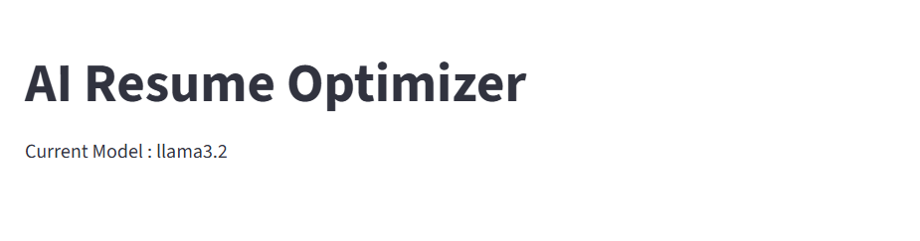
Interview Questions
- What is configuration management?
- What is hardcoding?
- Why is hardcoding discouraged in production applications?
- What is the purpose of a .env file?
- Why do we use os.getenv() instead of hardcoded values?
- What is the role of load_dotenv()?
- What is the difference between configuration and constants?
- Why should .env never be committed to Git?

Module 4 – Professional Logging System
Goal: By the end of this module, you will learn:
- What logging is
- Why logging is better than print()
- Log levels (INFO, WARNING, ERROR, etc.)
- How to configure logging
- How to log to both the console and a file
- How to use logging throughout the project
- Industry best practices

Part 1: What is Logging?
Logging is the process of recording what your application is doing.
Think of it as your application's diary.
Instead of:
print("Resume uploaded")
We use:
logger.info("Resume uploaded successfully.")

Now the message can appear:
- In the terminal
- In a log file
- With a timestamp
- With the log level
- With the module name and easy to debug

Part 2: Why Not Use print()?
Suppose your app crashes after deployment.
With print():
Resume Uploaded
Reading PDF
Connecting AI
Error
Problems:
- No timestamps
- No severity levels
- Not saved automatically
- Difficult to search
With logging:
2026-07-08 10:15:21 | INFO | Resume uploaded successfully
2026-07-08 10:15:22 | INFO | Extracting resume text
2026-07-08 10:15:23 | ERROR | Unable to connect to Ollama
This immediately tells you:
- When it happened
- Where it happened

Part 3: Logging Levels
Level | When to Use
DEBUG | Detailed developer information
INFO | Normal application events
WARNING | Something unexpected but the app continues
ERROR | An operation failed
CRITICAL | The application cannot continue

Example
logger.debug("Reading PDF page 1")
logger.info("Resume uploaded")
logger.warning("PDF has no images")
logger.error("Unable to connect to Ollama")
logger.critical("Application crashed")

Part 4: Create config/logging_config.py
Create:
config/
logging_config.py
Code
import logging
from pathlib import Path
from config.settings import LOG_LEVEL
# Create the logs directory if it doesn't exist
LOG_DIR = Path("logs")
LOG_DIR.mkdir(exist_ok=True)

# Log file path
LOG_FILE = LOG_DIR / "app.log"
def setup_logger() -> logging.Logger:
"""
Configure and return the application logger.
"""
logger = logging.getLogger("resume_optimizer")
# Prevent duplicate handlers if setup_logger() is called multiple times
if logger.hasHandlers():
return logger
logger.setLevel(LOG_LEVEL)
formatter = logging.Formatter(
"%(asctime)s | %(levelname)-8s | %(name)s | %(message)s"
)
# Console handler
console_handler = logging.StreamHandler()
console_handler.setFormatter(formatter)
# File handler
file_handler = logging.FileHandler(LOG_FILE, encoding="utf-8")
file_handler.setFormatter(formatter)
logger.addHandler(console_handler)
logger.addHandler(file_handler)
return logger

Part 5: Line-by-Line Explanation
Import logging
import logging
Imports Python's built-in logging library.
Import Path
from pathlib import Path
pathlib is the modern and recommended way to work with file paths.
Instead of:
"log/" + "app.log"
we use:
LOG_DIR / "app.log"
This works cleanly across Windows, Linux, and macOS.
Import Log Level
from config.settings import LOG_LEVEL
Reads the log level from your .env file.
Create Logs Folder
LOG_DIR = Path("logs")
LOG_DIR.mkdir(exist_ok=True)
If the logs folder doesn't exist, it is created automatically.
exist_ok=True means it won't raise an error if the folder already exists.
Log File
LOG_FILE = LOG_DIR / "app.log"
Creates the path:
logs/app.log
Create Logger
logger = logging.getLogger("resume_optimizer")
Creates a named logger.
Using a named logger makes it easier to identify messages from your application.
Prevent Duplicate Logs
if logger.hasHandlers():
return logger
Without this check, every call to setup_logger() would add new handlers, causing duplicate log messages.
Set Log Level
logger.setLevel(LOG_LEVEL)
Controls which log messages are recorded.
If LOG_LEVEL=INFO, then DEBUG messages are ignored.
Create Formatter
formatter = logging.Formatter(
"%(asctime)s | %(levelname)-8s | %(name)s | %(message)s"
)
This defines how log entries look.
Example:
2026-07-08 11:10:20 | INFO | resume_optimizer | Application started
Console Handler
console_handler = logging.StreamHandler()
Displays logs in the terminal.
File Handler
file_handler = logging.FileHandler(LOG_FILE, encoding="utf-8")
Writes logs to:
logs/app.log
Register Handlers
logger.addHandler(console_handler)
logger.addHandler(file_handler)
Now every log is written:
- to the terminal
- to the log file
Return Logger
return logger
Allows the logger to be reused anywhere in the project.

Part 6: Update app.py
Replace its contents with:
import streamlit as st
from config.settings import APP_NAME, MODEL_NAME
from config.logging_config import setup_logger
logger = setup_logger()
logger.info("Application started successfully.")
st.set_page_config(
page_title=APP_NAME,
page_icon="📄",
layout="wide"
)
st.title(APP_NAME)
st.write(f"Current Model: {MODEL_NAME}")
logger.info("Home page loaded.")

Part 7: Run the Application
streamlit run app.py

Expected Terminal Output
2026-07-08 11:10:20 | INFO | resume_optimizer | Application started successfully.
2026-07-08 11:10:21 | INFO | resume_optimizer | Home page loaded.

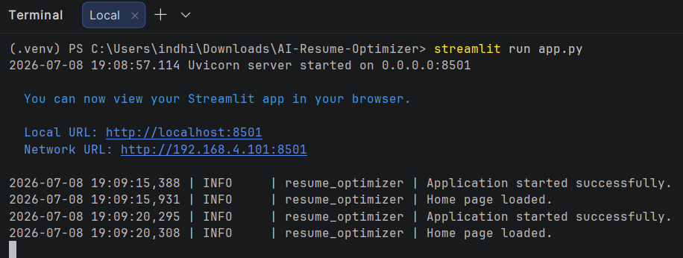

Expected Log File
Open:
logs/app.log
You should see the same messages.
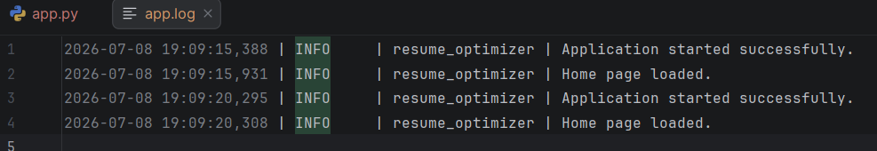

Part 8: Logging in Other Modules
Whenever we create a new module, we'll initialize the logger like this:
from config.logging_config import setup_logger
logger = setup_logger()
Then use it:
logger.info("Reading resume PDF.")
logger.warning("Resume contains no skills section.")
logger.error("Failed to extract PDF text.")
This keeps logging consistent across the project.

Interview Questions
- What is logging, and why is it important?
- Why is logging preferred over print() in production applications?
- Explain the different logging levels in Python.
- What is a logger, and why do we use a named logger?
- What is the purpose of a log formatter?
- Why do we use both a console handler and a file handler?
- Why should we avoid logging sensitive information?
- How does logger.hasHandlers() prevent duplicate log entries?

Module 5: Utility Layer & Helper Functions
Goal: By the end of this module, you will understand:
- What is a Utility Layer?
- Why helper functions are important
- DRY Principle (Don't Repeat Yourself)
- Creating reusable functions
- Type hints
- Docstrings
- Path handling using pathlib
- File validation
- Directory creation
- Exception handling
Part 1: What is a Utility Layer?
Imagine you have 10 Python files.
Each file contains:
import os
if not os.path.exists("uploads"):
os.makedirs("uploads")
Later you realize you wrote this same code in:
- app.py
- ats.py
- interview.py
- cover_letter.py
- jd_matcher.py
This is called code duplication.
Industry Solution
Create one function.
create_directory("uploads")
Now every module can reuse it.
This is called a Utility Layer.
What is DRY?
DRY means:
Don't Repeat Yourself
Bad:
if not os.path.exists(folder):
os.makedirs(folder)
Written 15 times.
Good:
create_directory(folder)
Written once.

Part 2: Create utils/__init__.py
Create an empty file.
utils/
__init__.py
Why?
This tells Python that utils is a package.

Part 3: Create utils/helpers.py
Create:
utils/helpers.py
This file will contain all reusable helper functions.
Code:
from pathlib import Path
from datetime import datetime
from config.logging_config import setup_logger
logger = setup_logger()
def create_directory(directory_path: str) -> Path:
"""
Create a directory if it does not exist.
Args:
directory_path (str): Directory path.
Returns:
Path: Path object of the directory.
"""
path = Path(directory_path)
path.mkdir(parents=True, exist_ok=True)

logger.info(f"Directory ready: {path}")
return path
def file_exists(file_path: str) -> bool:
"""
Check whether a file exists.
Args:
file_path (str): File path.
Returns:
bool
"""
exists = Path(file_path).is_file()
logger.info(f"File exists: {exists} -> {file_path}")
return exists
def get_file_extension(filename: str) -> str:
"""
Return file extension.
Args:
filename (str)
Returns:
str
"""
return Path(filename).suffix.lower().replace(".", "")
def get_current_timestamp() -> str:
"""
Return current timestamp.
Returns:
str
"""
return datetime.now().strftime("%Y-%m-%d %H:%M:%S")

Understanding Every Function
Function 1
create_directory()
Purpose
Creates a folder only if it doesn't already exist.
Instead of
if not os.path.exists("uploads"):
os.makedirs("uploads")
Simply call
create_directory("uploads")

Line  path = Path(directory_path)  Converts  uploads  into a Path object.  Why?  pathlib is the modern Python way. | Line  path.mkdir(parents=True, exist_ok=True)  Meaning  - Create the folder.  - If it already exists,  - don't raise an error.
Line
logger.info(...)
Every folder creation is logged.

Function 2  file_exists()  Purpose  Checks  Does this file exist?  Returns  True or False  Example  if file_exists("resume.pdf"):  print("Found") | Function 3  get_file_extension()  Suppose user uploads  Resume.PDF  Output  pdf  Even if  Resume.PDF  or  Resume.PDf  It always becomes lowercase. | Function 4  get_current_timestamp()  Returns  2026-07-08 18:45:02  Useful for  - logs  - output files  - reports  - history
Part 4: Using Helpers in app.py
Replace your current app.py with:
import streamlit as st
from config.settings import APP_NAME
from config.settings import MODEL_NAME
from config.logging_config import setup_logger
from utils.helpers import create_directory
from utils.helpers import get_current_timestamp
logger = setup_logger()
create_directory("uploads")
create_directory("outputs")
st.set_page_config(
page_title=APP_NAME,
page_icon="📄",
layout="wide"
)
logger.info("Application Started")
st.title(APP_NAME)
st.write(f"Current Model : {MODEL_NAME}")
st.write(f"Started At : {get_current_timestamp()}")
Output
Your Streamlit page should display something like:
AI Resume Optimizer
Current Model : llama3.2
Started At : 2026-07-08 18:45:02
The uploads/ and outputs/ directories will also be created automatically (if they don't already exist).
Why We Created helpers.py
Imagine after 6 months your project has:
- 35 Python files
- 18,000 lines of code
Whenever you need to:
- create a directory,
- check if a file exists,
- get a timestamp,
you don't rewrite the code—you reuse the helper functions.

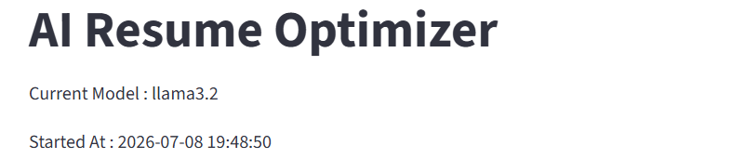

Best Practices
1. Keep Helper Functions Generic
Good:
create_directory()
Bad:
create_upload_directory()
Generic functions can be reused in many contexts.
2. One Responsibility Per Function
Each helper should do one thing only.
For example:
- file_exists() → checks existence.
- get_file_extension() → extracts the extension.
Don't combine multiple tasks into one function.
3. Use Type Hints
Example:
def file_exists(file_path: str) -> bool:
Benefits:
- Better IDE suggestions.
- Easier to understand.
- Helps catch mistakes early.
4. Write Docstrings
Every public function should explain:
- What it does.
- Its arguments.
- What it returns.
This improves maintainability.
5. Use pathlib Instead of os.path
pathlib is:
- Cleaner.
- Cross-platform.
- Easier to read.

Interview Questions
- What is the purpose of a utility layer?
- Explain the DRY principle.
- Why should helper functions be generic?
- What are the advantages of pathlib over os.path?
- What are type hints, and why are they useful?
- What is a docstring?
- Why should each function have a single responsibility?
- Why is code reuse important in software engineering?

Module 6: PDF Reader (Resume Extraction)
Goal: By the end of this module, you will build a production-ready PDF reader that can:
- Upload a resume (PDF)
- Validate the uploaded file
- Check the file extension
- Extract text from every page
- Handle corrupted PDFs
- Handle empty PDFs
- Log every step
- Return clean text for the AI model

Why Do We Need a PDF Reader?
Our AI (Llama 3.2) cannot read PDF files directly.
It only understands text.
For example:
Resume.pdf
↓
Extract Text
↓
Send Text to Llama 3.2
↓
AI Analysis
So the first step is converting the PDF into plain text.

Which Library Should We Use?
There are many PDF libraries:
Library | Recommendation
PyPDF2 | Good
pdfminer | Complex
fitz (PyMuPDF) | Excellent
pdfplumber | Best for resumes
We'll use pdfplumber because it extracts resume text accurately while remaining beginner-friendly.

Part 1: Create utils/pdf_reader.py
Create:
utils/
pdf_reader.py
Code:
"""
PDF Reader Module

This module is responsible for:
1. Validating PDF files
2. Extracting text from PDF resumes
3. Logging every operation
"""

from pathlib import Path
import pdfplumber
from config.logging_config import setup_logger
from config.constants import SUPPORTED_FILE_TYPES
from utils.helpers import get_file_extension
logger = setup_logger()
def extract_resume_text(file_path: str) -> str:
"""
Extract text from a resume PDF.
Args:
file_path (str): Path to the PDF file.
Returns:
str: Extracted resume text.
Raises:
ValueError:
If the file type is invalid or no text is found.
"""
logger.info(f"Reading resume: {file_path}")

# Validate file extension
extension = get_file_extension(file_path)
if extension not in SUPPORTED_FILE_TYPES:
logger.error("Unsupported file format.")
raise ValueError("Only PDF files are supported.")
resume_text = ""
try:
with pdfplumber.open(file_path) as pdf:
logger.info(f"Total Pages: {len(pdf.pages)}")
for page_number, page in enumerate(pdf.pages, start=1):
logger.info(f"Reading Page {page_number}")
page_text = page.extract_text()
if page_text:
resume_text += page_text + "\n"
except Exception as error:
logger.exception(error)
raise
if not resume_text.strip():
logger.warning("Resume contains no readable text.")
raise ValueError("No text found inside the PDF.")
logger.info("Resume extraction completed successfully.")
return resume_text.strip()

Line-by-Line Explanation
Module Docstring  """  PDF Reader Module  """  Every professional module starts with documentation. | Import Path  from pathlib import Path  Used for working with file paths.
Import pdfplumber  import pdfplumber  This library reads PDF files page by page. | Import Logger  from config.logging_config import setup_logger  Every module gets its own logger.
Import Constants  SUPPORTED_FILE_TYPES  Instead of:  if extension != "pdf":  we use centralized constants. | Import Helper  get_file_extension()  Notice we're reusing code from Module 5.  This is why we built the helper layer.
Logger  logger = setup_logger()  Every module initializes the shared logger. | Main Function  extract_resume_text()  This function is responsible for the entire PDF extraction process.
Validate Extension  extension = get_file_extension(file_path)  Example:  Resume.PDF  ↓  pdf | Check Allowed Types  if extension not in SUPPORTED_FILE_TYPES:  Rejects:  resume.docx  resume.png  resume.jpg

Open PDF  with pdfplumber.open(file_path) as pdf:  The with statement automatically closes the file after reading. | Loop Through Pages  for page_number, page in enumerate(pdf.pages, start=1):  If the resume has:  - 1 page  - 2 pages  - 10 pages  all pages are processed.
Extract Text  page.extract_text()  Returns:  John Doe  Skills  Python  SQL  Power BI | Store Text  resume_text += page_text + "\n"  Adds each page to the final result.
Exception Handling  except Exception as error:  Handles cases like:  - Corrupted PDFs  - Password-protected PDFs  - Invalid files  and logs the full error. | Empty Resume Check  Some PDFs contain only scanned images.  In that case:  page.extract_text()  returns:  None  We check:  if not resume_text.strip():  If no readable text exists, we raise an error.
Part 2: Update app.py
For now, we'll create a simple UI to test file uploads.
import streamlit as st
from config.settings import APP_NAME
from config.logging_config import setup_logger
logger = setup_logger()
st.set_page_config(
page_title=APP_NAME,
page_icon="📄",
layout="wide"
)
st.title(APP_NAME)
uploaded_file = st.file_uploader(
"Upload Resume",
type=["pdf"]
)
if uploaded_file:
save_path = f"uploads/{uploaded_file.name}"
with open(save_path, "wb") as file:
file.write(uploaded_file.getbuffer())
st.success("Resume uploaded successfully!")
logger.info(f"Resume saved: {save_path}")
What Happens Here?
User Uploads PDF Streamlit Receives File Save File uploads/
↓
Ready for Extraction

We're not extracting text yet. First, we verify the upload flow.

Part 3: Test pdf_reader.py
Create a temporary file:
from utils.pdf_reader import extract_resume_text
text = extract_resume_text("uploads/sample_resume.pdf")
print(text)
You should see the extracted resume text in the console.
Later, we'll integrate this into the Streamlit interface
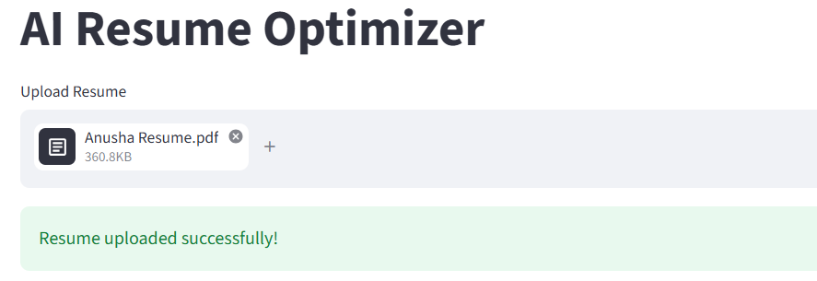
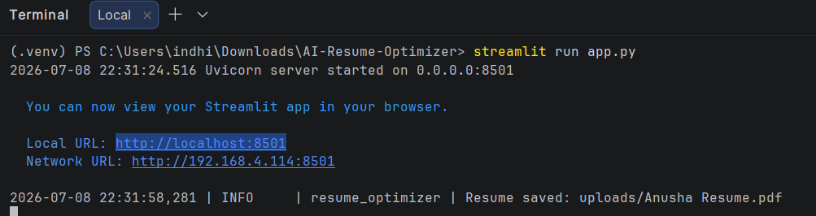

Interview Questions
- Why do we need to extract text from a PDF before sending it to an LLM?
- Why did we choose pdfplumber?
- Why do we validate file extensions?
- What is the purpose of a with statement?
- Why do we use logger.exception() instead of print()?
- What happens if page.extract_text() returns None?
- Why should exceptions be meaningful?

Module 7 – Connecting Ollama (Llama 3.2)
Goal: By the end of this module, you'll have a reusable Ollama Client that can:
- Connect to Ollama
- Send prompts to Llama 3.2
- Receive AI responses
- Handle errors gracefully
- Log all operations
- Be reused throughout the project
This client will be used by:
- ATS Analyzer
- Resume Rewriter
- Interview Question Generator
- Cover Letter Generator
- JD Matcher
- What is Ollama?
Ollama lets you run Large Language Models locally on your own computer.
Instead of:
Your App
│
OpenAI API
│
Internet
|
Response
We'll use:
Your App
│
Ollama
│
Llama 3.2
Advantages:
- Free
- Private
- Works offline (after downloading the model)
- No API key
- No token cost

- Architecture
Streamlit
│
ollama_client.py
│
Ollama Server
|
Llama 3.2
│
AI Response

3. Install Ollama
If you haven't already:
Download
https://ollama.com
Install it.
Verify Installation
Open Command Prompt:
ollama --version
Example:
ollama version 0.10.x
Download Llama 3.2
ollama pull llama3.2
Wait until the download finishes.
Start Ollama
ollama serve
Usually you'll see:
Listening on localhost:11434
Keep this terminal running.
Note: On Windows, Ollama often starts automatically as a background service. You can verify it's running with:
ollama list

4. Update requirements.txt
Add:
streamlit
ollama
pdfplumber
python-dotenv
pydantic
requests
If needed, install:
pip install ollama
5. Project Structure
AI-Resume-Optimizer/
│
├── utils/
│ │
│ ├── helpers.py
│ ├── pdf_reader.py
│ ├── ollama_client.py
│
├── config/
|
├── app.py
6. Create utils/ollama_client.py
Create:
utils/
ollama_client.py
Code:
"""
Ollama Client
This module communicates with the local Ollama server.
"""
from ollama import Client
from config.settings import MODEL_NAME, OLLAMA_HOST
from config.logging_config import setup_logger
logger = setup_logger()
# Create a reusable client
client = Client(host=OLLAMA_HOST)
def ask_ai(prompt: str) -> str:
"""
Send a prompt to the Ollama model.
Args:
prompt (str): Prompt to send.
Returns:
str: AI response.
"""
logger.info("Sending prompt to Ollama.")
try:
response = client.chat(
model=MODEL_NAME,
messages=[
{
"role": "user",
"content": prompt
}
]
)
answer = response["message"]["content"]
logger.info("Response received successfully.")
return answer
except Exception as error:
logger.exception(error)
raise

7. Understanding Every Line
Import Client
from ollama import Client
Instead of calling Ollama manually every time, we create one reusable client.
Import Settings
from config.settings import MODEL_NAME
Remember Module 3?
Instead of:
model="llama3.2"
We use:
MODEL_NAME
Now changing the model requires editing only .env.
Create Client
client = Client(host=OLLAMA_HOST)
Creates a connection to:
http://localhost:11434
This object will be reused across the application.
Main Function
ask_ai(prompt)
This becomes the central function for talking to the AI.
Every module will use it.
Send Request
response = client.chat(...)
This sends:
Prompt
↓
Ollama
↓
Llama 3.2
↓
Response
Messages
messages=[
{
"role":"user",
"content":prompt
}
]
This follows the chat format used by modern LLMs.
Later we'll add:
- System prompts
- Conversation history
- Memory
Read Response
Ollama returns something similar to:
{
"model":"llama3.2",
"message":{
"role":"assistant",
"content":"Hello!"
}
}
We extract:
response["message"]["content"]

Logging
logger.info(...)
Records:
- Prompt sent
- Response received
- Errors
Error Handling
except Exception as error:
Handles:
- Ollama not running
- Model missing
- Timeout
- Connection errors

8. Test the Client
Create a temporary file:
from utils.ollama_client import ask_ai
response = ask_ai(
"Say Hello in one sentence."
)
print(response)
Expected:
Hello! Nice to meet you.
9. Integrate with Streamlit
Update app.py:
import streamlit as st
from config.settings import APP_NAME
from utils.ollama_client import ask_ai
st.set_page_config(
page_title=APP_NAME,
page_icon="📄",
layout="wide"
)
st.title(APP_NAME)
if st.button("Test AI"):
with st.spinner("Thinking..."):
answer = ask_ai(
"Explain Artificial Intelligence in two lines."
)
st.success("Response received!")
st.write(answer)
Expected Output
Click:
Test AI
Output:
Artificial Intelligence is a field of computer science that enables machines to perform tasks requiring human intelligence. It includes learning, reasoning, and problem-solving.
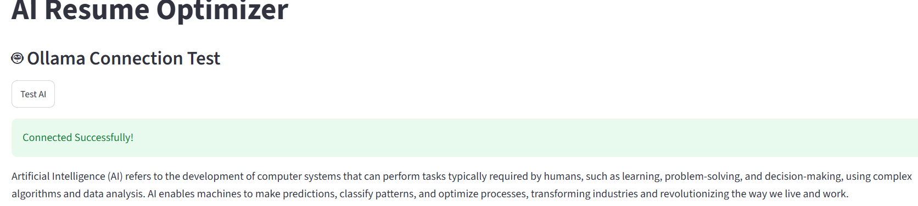

Interview Questions
- What is Ollama?
- Why use Ollama instead of a cloud API?
- What is the purpose of Client(host=...)?
- Why do we keep AI communication in a separate module?
- Why shouldn't we hardcode the model name?
- What is the purpose of the messages parameter?
- How do you handle connection failures to an LLM service?
- Why is logging important in AI applications?

Module 8 – Prompt Engineering & Prompt Management System
Goal: By the end of this module, you will learn:
- What Prompt Engineering is
- Why prompts should never be hardcoded
- How to create reusable prompt templates
- How to organize prompts professionally
- How to load prompts dynamically
- How to use placeholders
- How to create different prompt files for different AI tasks
1. What is Prompt Engineering?
A prompt is simply the instruction we give to the AI.
Example:
Summarize this resume.
The AI responds based on that instruction.
Prompt Engineering is the skill of designing prompts that produce accurate, structured, and reliable outputs.

2. Bad vs Good Prompt
Bad Prompt:
Analyze this resume.
Possible problems:
- Vague
- No structure
- Different output every time
Good Prompt:
You are an ATS Resume Expert.
Analyze the following resume.
Provide:
1. ATS Score (0–100)
2. Strengths
3. Weaknesses
4. Missing Skills
5. Improvement Suggestions
Return the answer in Markdown.
This gives the AI a clear role, clear task, and expected output format.

3. Why Not Hardcode Prompts?
Many beginners write:
prompt = """
Analyze this resume...
"""
inside ats.py.
Problems:
- Hard to edit
- Repeated in many files
- Mixes business logic with prompt text
Solutions:
Store prompts in separate text files.
prompts/
ats_prompt.txt
rewrite_prompt.txt
interview_prompt.txt
cover_letter_prompt.txt
jd_match_prompt.txt
Now prompt engineers can update prompts without touching Python code.

4. Project Structure
AI-Resume-Optimizer/
│
├── prompts/
│ │
│ ├── ats_prompt.txt
│ ├── rewrite_prompt.txt
│ ├── interview_prompt.txt
│ ├── cover_letter_prompt.txt
│ └── jd_match_prompt.txt
│
├── utils/
│ │
│ ├── prompt_loader.py
│ ├── ollama_client.py
│ └── pdf_reader.py

5. Create Your First Prompt
prompts/ats_prompt.txt
You are an expert ATS (Applicant Tracking System) Resume Reviewer.
Analyze the resume below.
Resume:
{resume}
Please provide:
1. ATS Score (0-100)
2. Strengths
3. Weaknesses
4. Missing Skills
5. Grammar Issues
6. Formatting Suggestions
7. Final Recommendations
Return the answer in Markdown format.
Notice:
{resume}
This is a placeholder.
Later Python will replace it with the extracted resume text.

6. Create utils/prompt_loader.py
Create:
utils/
prompt_loader.py

Code:
"""
Prompt Loader
Loads prompt templates from the prompts folder.
"""
from pathlib import Path
from config.logging_config import setup_logger
logger = setup_logger()
PROMPT_FOLDER = Path("prompts")
def load_prompt(file_name: str) -> str:
"""
Load a prompt template from the prompts directory.
Args:
file_name (str): Name of the prompt file.
Returns:
str: Prompt template.
"""
prompt_path = PROMPT_FOLDER / file_name
logger.info(f"Loading prompt: {prompt_path}")
if not prompt_path.exists():
logger.error(f"Prompt not found: {prompt_path}")
raise FileNotFoundError(f"{prompt_path} does not exist.")
with open(prompt_path, "r", encoding="utf-8") as file:
prompt = file.read()
logger.info("Prompt loaded successfully.")
return prompt

Line-by-Line Explanation
Create Prompt Folder Path
PROMPT_FOLDER = Path("prompts")
This points to the prompts/ directory.
Build File Path
prompt_path = PROMPT_FOLDER / file_name
If:
file_name = "ats_prompt.txt"
Result:
prompts/ats_prompt.txt
Check if File Exists
if not prompt_path.exists():
If missing:
Raise:
FileNotFoundError
Read Prompt
with open(...)
Reads the entire prompt into a string.
Return Prompt
return prompt
Now any module can load it.

7. Testing Prompt Loader
Create a temporary test:
from utils.prompt_loader import load_prompt
prompt = load_prompt("ats_prompt.txt")
print(prompt)
Expected output:
You are an expert ATS Resume Reviewer...
8. Using Placeholders
The prompt contains:
{resume}
Suppose extracted resume text is:
John Doe
Python
SQL
Power BI
Replace it:
resume_text = """
John Doe
Python
SQL
Power BI
"""
prompt = load_prompt("ats_prompt.txt")
final_prompt = prompt.format(
resume=resume_text
)
print(final_prompt)
Result:
Resume:
John Doe
Python
SQL
Power BI
Provide:
ATS Score...
This dynamic approach allows the same prompt template to be reused for any resume.

9. Future Prompt Files
We'll create additional prompt templates as we build features.
rewrite_prompt.txt
You are a professional Resume Writer.
Rewrite the resume below to improve ATS compatibility.
Resume:
{resume}
interview_prompt.txt
Generate 15 interview questions based on this resume.
Resume:
{resume}
cover_letter_prompt.txt
Write a professional cover letter using:
Resume:
{resume}
Job Description:
{job_description}
jd_match_prompt.txt
Compare the resume with the job description.
Resume:
{resume}
Job Description:
{job_description}
Provide:
- Match Percentage, Missing Skills, Suggestions

10. Update app.py
For now, let's test the prompt system.
import streamlit as st
from config.settings import APP_NAME
from utils.prompt_loader import load_prompt
st.set_page_config(
page_title=APP_NAME,
page_icon="📄",
layout="wide"
)
st.title(APP_NAME)
if st.button("Load ATS Prompt"):
prompt = load_prompt("ats_prompt.txt")
st.text_area(
"Prompt Preview",
prompt,
height=400
)
Clicking the button should display the contents of ats_prompt.txt.

Best Practices
1. Keep Prompts Outside Python
Never write long prompts inside .py files.
2. One Prompt Per Task
Good:
- ats_prompt.txt
- interview_prompt.txt
- rewrite_prompt.txt
Avoid combining multiple tasks into one prompt.
3. Use Placeholders
Instead of hardcoding resume text:
John Doe
Use:
{resume}
This keeps templates reusable.
4. Version Prompts
As the project grows, you might have:
ats_prompt_v1.txt
ats_prompt_v2.txt
This allows safe experimentation without breaking existing behavior.

Output:
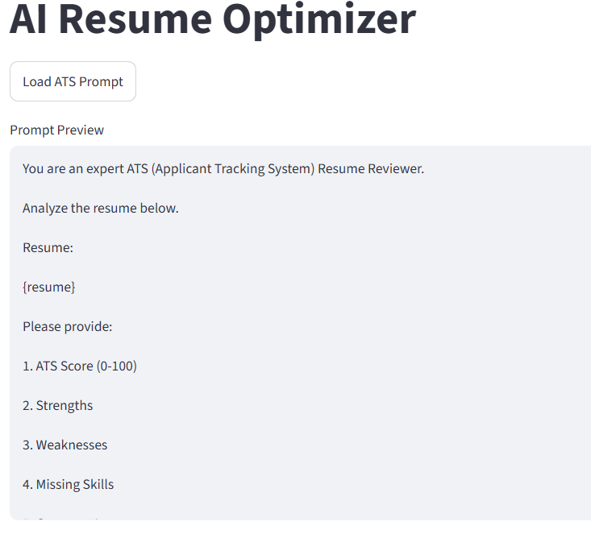

Interview Questions
- What is Prompt Engineering?
- Why should prompts be stored outside Python code?
- What are placeholders in prompt templates?
- Why is prompt versioning useful?
- What are the benefits of separating prompts from application logic?
- How do you dynamically insert user data into a prompt?
- Why should each AI task have its own prompt template?

Module 9 – ATS Resume Analyzer
Goal: By the end of this module, your application will:
Upload Resume
│
Save PDF
│
Extract Resume Text
│
Load ATS Prompt
│
Insert Resume into Prompt
│
Send to Ollama
│
Receive ATS Analysis
│
Display Professional Report
This is the first complete AI workflow in our project.
Module Overview
In this module, we will build:
ATS Resume Analyzer
│
├── Upload Resume
├── Extract Resume Text
├── Load Prompt
├── Send Prompt to LLM
├── Receive Response
├── Display Analysis
└── Save Output
Project Structure
AI-Resume-Optimizer/
│
├── app.py
├── config/
├── prompts/
│ ats_prompt.txt
├── utils/
│ helpers.py
│ pdf_reader.py
│ prompt_loader.py
│ ollama_client.py
│ ats.py NEW
├── uploads/
├── outputs/
├── logs/

Why Create ats.py?
Many beginners write everything inside app.py.
Example:
Upload
↓
Read PDF
↓
Load Prompt
↓
Call AI
↓
Display
After a few weeks, app.py becomes 800–1000 lines long.
That is hard to maintain.
To handle this we use:
Business logic goes into separate modules.
app.py
↓
analyze_resume()
↓
ats.py
This keeps app.py clean.

Step 1 – Create utils/ats.py
Create:
utils/
ats.py
Code:  """  ATS Resume Analyzer  This module coordinates:  1. Resume text extraction  2. Prompt loading  3. AI analysis  """  from config.logging_config import setup_logger  from utils.pdf_reader import extract_resume_text  from utils.prompt_loader import load_prompt  from utils.ollama_client import ask_ai  logger = setup_logger()  def analyze_resume(pdf_path: str) -> str:  """  Analyze a resume using the ATS prompt.  Args:  pdf_path (str): Path to the uploaded resume.  Returns:  str: AI-generated ATS analysis.  """  logger.info("Starting ATS analysis.")  # Step 1: Extract resume text  resume_text = extract_resume_text(pdf_path)  logger.info("Resume text extracted.")  # Step 2: Load ATS prompt  prompt = load_prompt("ats_prompt.txt")  logger.info("ATS prompt loaded.")  # Step 3: Insert resume into prompt  final_prompt = prompt.format(  resume=resume_text  )  logger.info("Prompt prepared.")  # Step 4: Send to AI  response = ask_ai(final_prompt)  logger.info("ATS analysis completed.")  return response | Flow Diagram  PDF  ↓  extract_resume_text()  ↓  Resume Text  ↓  load_prompt()  ↓  ATS Prompt  ↓  prompt.format()  ↓  Final Prompt  ↓  ask_ai()  ↓  LLM  ↓  Response
Update app.py
Replace your Resume Upload section with the following.
# ---------------------------------------------------
# Resume Analyzer
# ---------------------------------------------------
from utils.ats import analyze_resume
st.subheader("ATS Resume Analyzer")
uploaded_file = st.file_uploader(
"Upload Resume",
type=["pdf"]
)
if uploaded_file:
save_path = f"uploads/{uploaded_file.name}"
with open(save_path, "wb") as file:
file.write(uploaded_file.getbuffer())
st.success("Resume Uploaded Successfully")
if st.button("Analyze Resume"):
with st.spinner("Analyzing Resume..."):
try:
analysis = analyze_resume(save_path)
st.success("Analysis Completed!")
st.markdown(analysis)
except Exception as error:
logger.exception(error)
st.error(error)
What Happens Internally?
Suppose the uploaded resume contains:
John Doe
Python
SQL
Power BI
Excel
The prompt loader loads:
You are an ATS Expert.
Resume:
{resume}
Provide:
ATS Score
Strengths
Weaknesses
...
Python replaces:
{resume}
with
John Doe
Python
SQL
Power BI
Excel
The final prompt is sent to Llama 3.2.
Expected AI Output
ATS Score: 82/100
Strengths
• Strong SQL knowledge
• Power BI experience
• Python programming
Weaknesses
• Missing Git
• Missing Cloud Skills
Suggestions
• Add measurable achievements
• Include certifications
• Improve project descriptions
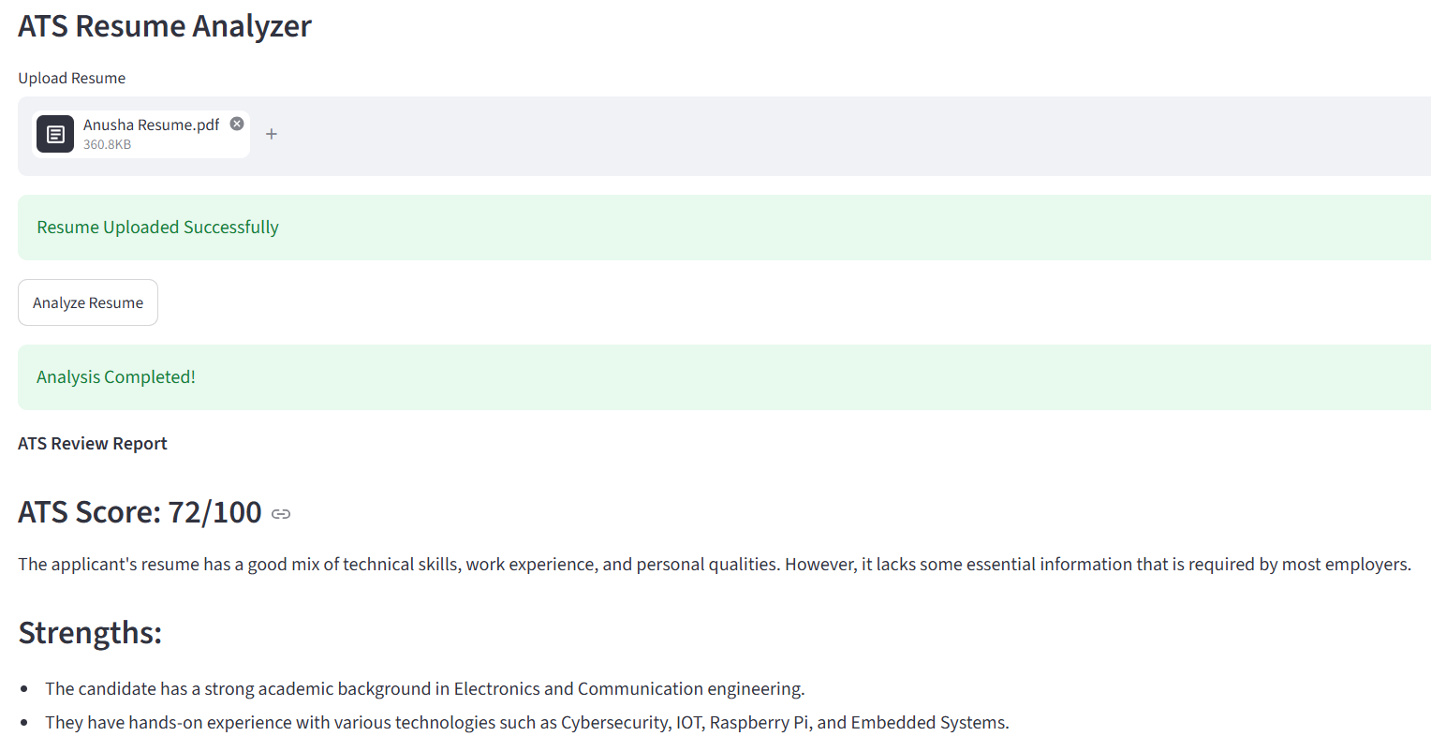

Save AI Output (Optional but Recommended)
Add this helper function to utils/helpers.py:
from pathlib import Path
def save_text_file(file_path: str, content: str):
Path(file_path).write_text(
content,
encoding="utf-8"
)
Then in app.py:
from utils.helpers import save_text_file
save_text_file(
"outputs/ats_report.md",
analysis
)
Now every analysis is saved automatically.

Interview Questions
- Why is ats.py separated from app.py?
- Explain the complete ATS analysis workflow.
- Why should business logic not be written in the UI layer?
- What is the Single Responsibility Principle?
- Why are prompt templates stored separately?
- How does prompt.format() work?
- What are the advantages of modular architecture?

Module 10 – Structured AI Output (JSON)
Goal: By the end of this module, your application will:
Resume
↓
Llama 3.2
↓
JSON Response
↓
Validate JSON
↓
Convert to Python Dictionary
↓
Display Beautiful Dashboard
Instead of getting:
ATS Score : 80
Strengths
Python
SQL
Power BI
We'll receive:
{
"ats_score": 80,
"strengths": [
"Python",
"SQL",
"Power BI"
],
"weaknesses": [
"No Cloud Skills",
"No Git"
],
"missing_skills": [
"Docker",
"AWS"
],
"recommendations": [
"Add Certifications",
"Improve Project Descriptions"
]
}

Why JSON?  Imagine you want to show this in Streamlit.  Plain text:  ATS Score : 85  How will Python know that 85 is the score?  It can't.  With JSON:  result["ats_score"]  returns  85 | New Architecture  Resume  ↓  Prompt  ↓  Llama 3.2  ↓  JSON  ↓  Parser  ↓  Python Dictionary  ↓  Streamlit Dashboard

Project Structure
AI-Resume-Optimizer/
│
├── utils/
│ │
│ ├── ats.py
│ ├── json_parser.py NEW
│
├── prompts/
│ ats_prompt.txt

Step 1 — Update ATS Prompt
Replace prompts/ats_prompt.txt
with
You are an expert ATS Resume Reviewer.
Analyze the following resume.
Resume
{resume}
Return ONLY valid JSON.
Do not write explanations.
Do not write markdown.
Do not use triple backticks.
Return exactly this format:
{
"ats_score": 0,
"strengths": [],
"weaknesses": [],
"missing_skills": [],
"grammar_issues": [],
"recommendations": []
}
Notice
Return ONLY valid JSON.
This is one of the most important prompt engineering techniques.
Why?
Without it,
Llama might answer
Here is the analysis.
```json
{
...
}
That breaks our parser.
---

Step 2 — Create `json_parser.py`
Create:
utils/
json_parser.py
Code:

"""
JSON Parser
Converts AI response into Python dictionary.
"""

import json
from config.logging_config import setup_logger
logger = setup_logger()
def parse_json(ai_response: str) -> dict:
"""
Convert AI JSON string into Python dictionary.
Args:
ai_response (str)
Returns:
dict
"""
try:
result = json.loads(ai_response)
logger.info("JSON parsed successfully.")
return result
except json.JSONDecodeError as error:
logger.exception(error)
raise ValueError(
"AI returned invalid JSON."
)
What is json.loads()?
Suppose AI returns
{
"ats_score":90
}
It is still just text.
After
json.loads()
It becomes
{
"ats_score":90
}
which is a Python dictionary.

Step 3 — Update ats.py  Replace  response = ask_ai(final_prompt)  return response  with  from utils.json_parser import parse_json  response = ask_ai(final_prompt)  result = parse_json(response)  return result  Now  analyze_resume()  returns  dict  instead of  string | Step 4 — Update app.py  Replace  st.markdown(analysis)  with  st.metric(  "ATS Score",  analysis["ats_score"]  )  st.subheader("Strengths")  for item in analysis["strengths"]:  st.success(item)  st.subheader("Weaknesses")  for item in analysis["weaknesses"]:  st.error(item)  st.subheader("Missing Skills")  for item in analysis["missing_skills"]:  st.warning(item)  st.subheader("Grammar Issues")  for item in analysis["grammar_issues"]:  st.info(item)  st.subheader("Recommendations")  for item in analysis["recommendations"]:  st.write("✅", item)

Output
Instead of
ATS Score : 85
You'll now see
+----------------------+
ATS SCORE
85
+----------------------+
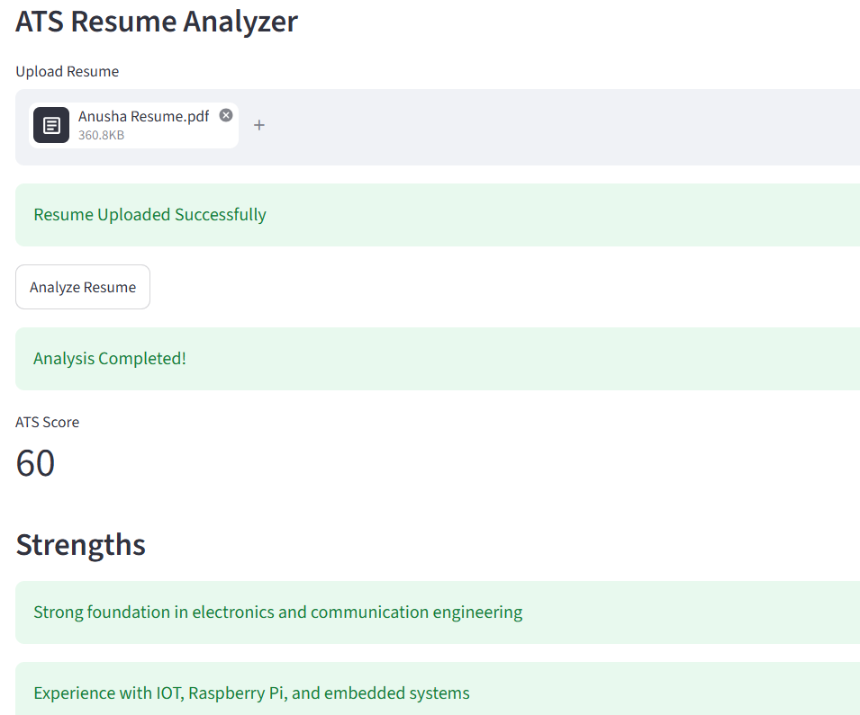
Interview Questions
- Why is JSON preferred over plain text in AI applications?
- What does json.loads() do?
- Why should AI responses always be validated?
- What is a JSONDecodeError?
- How do you handle malformed AI output?
- Why should the UI work with Python dictionaries instead of raw strings?

Module 11 Production-Ready AI Response Validation
Goal: By the end of this module, your application will:
- Validate every AI response.
- Retry automatically if the response is invalid.
- Handle malformed JSON gracefully.
- Prevent crashes caused by missing fields.
- Follow enterprise GenAI architecture.
Current Flow (Module 10)  Resume  │  Extract Resume Text  │  Prompt  │  Llama 3.2  │  json.loads()  │  Streamlit  Problem:  If AI returns invalid JSON  ↓  Application crashes | New Flow (Module 11)  Resume  │  Prompt  │  Llama 3.2  │  Clean Response  │  Parse JSON  │  Validate Schema  │  Retry if Invalid  │  Streamlit UI

Project Structure
After Module 11:
AI-Resume-Optimizer/
│
├── app.py
├── config/
│ ├── settings.py
│ ├── logging_config.py
├── models/
│ ├── __init__.py
│ └── ats_schema.py NEW
├── utils/
│ ├── ats.py
│ ├── json_parser.py
│ ├── response_validator.py NEW
│ ├── ollama_client.py
│ ├── helpers.py
│ ├── pdf_reader.py
│ └── prompt_loader.py
├── prompts/
│ └── ats_prompt.txt

Step 1 — Install Pydantic
In the PyCharm terminal:
pip install pydantic
Update requirements.txt
streamlit
pymupdf
ollama
python-dotenv
pydantic

Pydantic is a Python library that validates and parses data using type hints, ensuring data is correct, consistent, and easy to work with.
Why use Pydantic?
- Validates input data automatically
- Converts data to the correct type when possible
- Reduces errors and makes code more reliable
- Commonly used with FastAPI, AI applications, and APIs
Example
from pydantic import BaseModel
class Student(BaseModel):
name: str
age: int
student = Student(name="John", age="20")
print(student)
Output:
name='John' age=20
Notice that "20" (a string) was automatically converted to the integer 20.

Step 2 — Create models/ats_schema.py
"""
ATS Response Schema
"""
from pydantic import BaseModel, Field
class ATSReport(BaseModel):
ats_score: int = Field(default=0)
strengths: list[str] = Field(default_factory=list)
weaknesses: list[str] = Field(default_factory=list)
missing_skills: list[str] = Field(default_factory=list)
grammar_issues: list[str] = Field(default_factory=list)
recommendations: list[str] = Field(default_factory=list)
Step 3 — Create utils/response_validator.py
"""
Validate AI Response
"""
from pydantic import ValidationError
from models.ats_schema import ATSReport
from config.logging_config import setup_logger
logger = setup_logger()
def validate_ats_response(data: dict) -> dict:
"""
Validate AI response using Pydantic.
"""
try:
report = ATSReport(**data)
logger.info("AI response validated successfully.")
return report.model_dump()
except ValidationError as error:
logger.exception(error)
raise ValueError(
"Invalid AI response structure."
)
Step 4 — Update json_parser.py
Replace your parser with:
"""
JSON Parser
"""
import json
import re
from config.logging_config import setup_logger
from utils.response_validator import validate_ats_response
logger = setup_logger()
def parse_json(ai_response: str) -> dict:
"""
Parse and validate AI JSON response.
"""
try:
cleaned = ai_response.strip()
cleaned = cleaned.replace("```json", "")
cleaned = cleaned.replace("```", "")
start = cleaned.find("{")
end = cleaned.rfind("}")
if start != -1 and end != -1:
cleaned = cleaned[start:end + 1]
cleaned = re.sub(r",\s*}", "}", cleaned)
cleaned = re.sub(r",\s*]", "]", cleaned)
data = json.loads(cleaned)
validated = validate_ats_response(data)
logger.info("JSON parsed successfully.")
return validated
except Exception as error:
logger.exception(error)
raise ValueError(
"AI returned invalid JSON."
)
Step 5 — Update utils/ats.py
Replace the AI call with retry logic:
MAX_RETRIES = 2
for attempt in range(MAX_RETRIES):
ai_response = ask_ai(final_prompt)
try:
result = parse_json(ai_response)
logger.info("ATS analysis completed.")
return result
except Exception:
logger.warning(
f"Retry {attempt + 1} due to invalid AI response."
)
raise ValueError(
"Unable to obtain a valid AI response after multiple attempts."
)
Why Retry?
Sometimes the model produces:
{
"ats_score": 80,
...
and stops before finishing.
Instead of showing an error immediately, the application automatically asks the model again.
This is a common pattern in production AI systems.

Step 6 — Improve the Prompt
Update prompts/ats_prompt.txt:
You are an expert ATS Resume Reviewer.
Analyze the following resume.
Resume:
{resume}
Rules:
1. Return ONLY valid JSON.
2. Do NOT use markdown.
3. Do NOT explain anything.
4. Every key must exist.
5. If there is no value, return an empty list.
6. Maximum 4 items per list.
7. Keep recommendations short.
Return exactly this JSON format:
{{
"ats_score": 0,
"strengths": [],
"weaknesses": [],
"missing_skills": [],
"grammar_issues": [],
"recommendations": []
}}

Step 7 — Improve Error Handling in app.py
Instead of:
st.error(error)
use:
st.error(
"Unable to analyze the resume. Please try again."
)
logger.exception(error)
Users should see friendly messages, while detailed errors remain in your logs.

Interview Questions
- Why should LLM responses be validated?
- What problem does Pydantic solve?
- What is the difference between parsing and validation?
- Why is retry logic useful with LLMs?
- How would you make an AI application resilient to malformed outputs?

Module 12 — AI Resume Rewriter
Goal: By the end of this module, you will know:
- Prompt Engineering for rewriting
- Prompt templates
- AI text transformation
- Streamlit tabs
- Saving generated output
- Downloading files
- Error handling
- Logging
- Modular architecture
Now we Will Build
The Resume Rewriter will take a resume and rewrite it professionally.
Use Cases
This feature is similar to tools offered by:
- Resume.io
- Rezi AI
- Kickresume AI
- Teal AI
- Enhancv AI
This is a strong portfolio feature for interviews.

Structure
Add the following:
AI-Resume-Optimizer/
|
prompts/
│
├── ats_prompt.txt
├── rewrite_prompt.txt NEW
|
utils/
│
├── resume_rewriter.py NEW
|
outputs/

Step 1 — Create prompts/rewrite_prompt.txt
You are an expert Resume Writer and ATS Specialist.
Rewrite the following resume professionally.
Rules:
1. Improve grammar.
2. Improve readability.
3. Improve ATS compatibility.
4. Keep all factual information unchanged.
5. Do NOT invent experience.
6. Do NOT invent skills.
7. Use professional language.
8. Improve formatting.
9. Keep section headings clear.
10. Return ONLY the rewritten resume.
Resume
{resume}
This prompt is called a Transformation Prompt.
Unlike the ATS prompt, which analyzes the input, this prompt transforms it.

Step 2 — Create utils/resume_rewriter.py
from config.logging_config import setup_logger
from utils.pdf_reader import extract_resume_text
from utils.prompt_loader import load_prompt
from utils.ollama_client import ask_ai
logger = setup_logger()
def rewrite_resume(pdf_path: str) -> str:
"""
Rewrite resume using AI.
"""
logger.info("Starting Resume Rewrite")
resume = extract_resume_text(pdf_path)
logger.info("Resume extracted")
prompt = load_prompt("rewrite_prompt.txt")
logger.info("Rewrite prompt loaded")
final_prompt = prompt.format(
resume=resume
)
logger.info("Prompt prepared")
rewritten_resume = ask_ai(final_prompt)
logger.info("Resume rewritten successfully")
return rewritten_resume

Architecture
Resume
↓
PDF Reader
↓
Prompt Loader
↓
Prompt Template
↓
Ollama
↓
Rewritten Resume

Step 3 — Update helpers.py
Add this function:
def save_text(file_path: str, text: str):
"""
Save text to a file.
"""
with open(
file_path,
"w",
encoding="utf-8"
) as file:
file.write(text)
logger.info(f"Saved file: {file_path}")
Step 4 — Update app.py
Import:
from utils.resume_rewriter import rewrite_resume
from utils.helpers import save_text

Below the ATS section, add:
st.markdown("---")
st.header("AI Resume Rewriter")
rewrite_file = st.file_uploader(
"Upload Resume to Rewrite",
type=["pdf"],
key="rewrite"
)
if rewrite_file:
rewrite_path = f"uploads/{rewrite_file.name}"
with open(rewrite_path, "wb") as file:
file.write(rewrite_file.getbuffer())
st.success("Resume uploaded successfully.")
if st.button("Rewrite Resume"):
with st.spinner("AI is rewriting your resume..."):
try:
rewritten = rewrite_resume(rewrite_path)
st.success("Resume rewritten successfully.")
st.text_area(
"Rewritten Resume",
rewritten,
height=500 )
output_path = "outputs/rewritten_resume.txt"
save_text(
output_path,
rewritten )
with open(
output_path,
"rb"
) as file:
st.download_button(
"Download Resume",
file,
file_name="rewritten_resume.txt" )
except Exception as error:
logger.exception(error)
st.error(str(error))

User Experience
Upload Resume
↓
Rewrite Resume
↓
Spinner
↓
Improved Resume
↓
Download Button
Example
Input:
Worked on Python project.
AI Output:
Developed Python-based applications by implementing efficient solutions and following industry-standard coding practices, demonstrating strong problem-solving abilities.
The AI improves the language without inventing new experience.

Output:

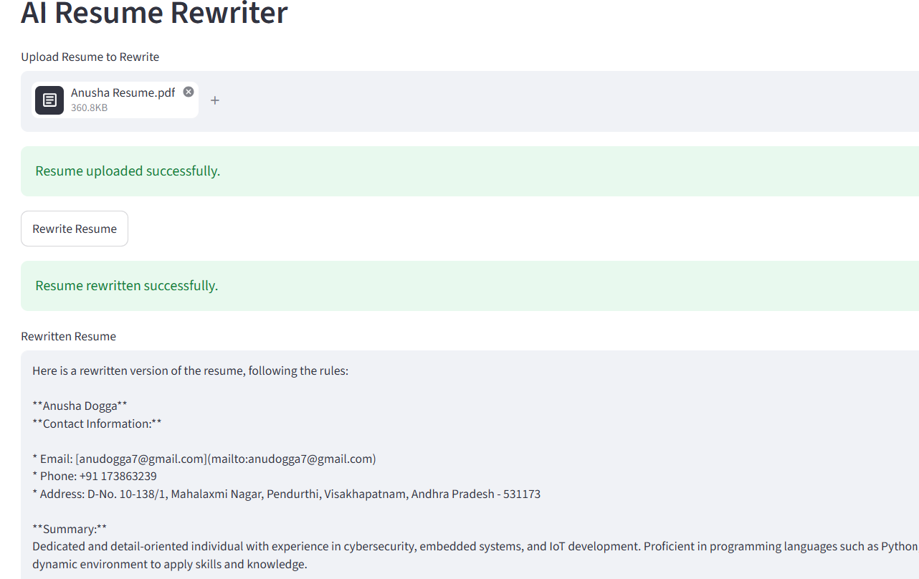

Interview Questions
- What is a transformation prompt?
- Why shouldn't AI invent skills or experience?
- Why keep prompts in separate files?
- Why save AI-generated output?
- How would you improve the rewrite quality while keeping factual accuracy?

Module 13: AI Job Description (JD) Matcher
Goal: By the end of Module 13, we'll learn:
- Comparing two documents using AI
- Multi-input Prompt Engineering
- JSON response generation
- Reusing your existing AI pipeline
- Dashboard visualization
- Modular architecture

Project Structure
Add the following files:
AI-Resume-Optimizer/
|
prompts/
│
├── ats_prompt.txt
├── rewrite_prompt.txt
├── jd_match_prompt.txt NEW
|
utils/
│
├── ats.py
├── resume_rewriter.py
├── jd_matcher.py NEW
|
models/
│
├── ats_schema.py
├── jd_schema.py NEW
JD Matching compares two inputs:
Resume
\
\
AI
/
Job Description
↓
Comparison
This is called Context Comparison Prompting.
Step 1 — Create jd_match_prompt.txt
Create:
prompts/jd_match_prompt.txt
Code:
You are an expert ATS Resume Matcher.
Compare the Resume with the Job Description.
Resume
{resume}
Job Description
{job_description}
Rules:
1. Return ONLY valid JSON.
2. Do not use markdown.
3. Do not explain.
4. Every key must exist.
5. Maximum 5 items in every list.
Return exactly this format.
{{
"match_score": 0,
"matching_skills": [],
"missing_skills": [],
"strengths": [],
"weaknesses": [],
"recommendations": []
}}

Step 2 — Create JD Schema
Create:
models/jd_schema.py
Code:
from pydantic import BaseModel, Field
class JDMatchReport(BaseModel):
match_score: int = Field(default=0)
matching_skills: list[str] = Field(default_factory=list)
missing_skills: list[str] = Field(default_factory=list)
strengths: list[str] = Field(default_factory=list)
weaknesses: list[str] = Field(default_factory=list)
recommendations: list[str] = Field(default_factory=list)

Step 3 — Create jd matcher
Create:
utils/jd_matcher.py
Code:
from config.logging_config import setup_logger
from utils.pdf_reader import extract_resume_text
from utils.prompt_loader import load_prompt
from utils.ollama_client import ask_ai
from utils.json_parser import parse_json
logger = setup_logger()
def match_resume_with_jd(
pdf_path: str,
job_description: str
) -> dict:
logger.info("Starting JD Matching")
resume = extract_resume_text(pdf_path)
logger.info("Resume extracted")
prompt = load_prompt(
"jd_match_prompt.txt"
)
logger.info("JD prompt loaded")
final_prompt = prompt.format(
resume=resume,
job_description=job_description
)
logger.info("Prompt prepared")
response = ask_ai(final_prompt)
result = parse_json(response)
logger.info("JD Matching completed")
return result

Step 4 — Update response_validator.py
Add a new function:
from models.jd_schema import JDMatchReport
def validate_jd_response(data: dict):
report = JDMatchReport(**data)
return report.model_dump()
updated one:
from pydantic import ValidationError
from config.logging_config import setup_logger
from models.ats_schema import ATSReport
from models.jd_schema import JDMatchReport
logger = setup_logger()
def validate_ats_response(data: dict) -> dict:
try:
report = ATSReport(**data)
return report.model_dump()
except ValidationError as error:
logger.exception(error)
raise ValueError(
"Invalid ATS Response"
)
def validate_jd_response(data: dict) -> dict:
try:
report = JDMatchReport(**data)
return report.model_dump()
except ValidationError as error:
logger.exception(error)
raise ValueError(
"Invalid JD Response"
)

Step 5 — Update json_parser.py
Updated Code:
"""
JSON Parser Utility
This module cleans, parses, and validates
AI responses returned by Ollama.
Supports:
1. ATS Analysis
2. JD Matching
Author: AI Resume Optimizer
"""
import json
import re
from config.logging_config import setup_logger
from utils.response_validator import (
validate_ats_response,
validate_jd_response )
logger = setup_logger()
def clean_json(text: str) -> str:
if not text:
return ""
# Remove Markdown code blocks
text = text.replace("```json", "")
text = text.replace("```", "")
# Remove leading/trailing spaces
text = text.strip()
# Keep only JSON object
start = text.find("{")
end = text.rfind("}")
if start != -1 and end != -1:
text = text[start:end + 1]
# Remove trailing commas
text = re.sub(r",\s*}", "}", text)
text = re.sub(r",\s*]", "]", text)
return text
def parse_json(
ai_response: str,
response_type: str = "ats"
) -> dict:
try:
cleaned = clean_json(ai_response)
logger.info("AI response cleaned.")
data = json.loads(cleaned)
logger.info("JSON parsed successfully.")
if response_type == "ats":
validated = validate_ats_response(
data
)
elif response_type == "jd":
validated = validate_jd_response(
data
)
else:
validated = data
logger.info(
"Response validated successfully."
)
return validated
except json.JSONDecodeError as error:
logger.exception(error)
logger.error(
"Invalid JSON returned by AI."
)
logger.error(ai_response)
raise ValueError(
"AI returned invalid JSON."
)
except Exception as error:
logger.exception(error)
raise
Now your parser supports different AI features.

Step 6 — Update jd_matcher.py and ats.py
Use:
result = parse_json(
response,
response_type="jd"
)
instead of:
parse_json(response)

Interview Questions
- What is Context Comparison Prompting?
- Why use separate prompt templates for each AI feature?
- Why should ATS analysis and JD matching have different schemas?
- How does modular architecture improve maintainability?
- How would you improve the accuracy of the match score?

Module 14 – AI Cover Letter Generator
Goal: Build an AI-powered cover letter generator that creates a personalized cover letter using:
- Resume (PDF)
- Job Description
- Company Name
- Job Role

Structure
After Module 14:
AI-Resume-Optimizer/
|
prompts/
│
├── ats_prompt.txt
├── rewrite_prompt.txt
├── jd_match_prompt.txt
├── cover_letter_prompt.txt NEW
|
utils/
│
├── ats.py
├── resume_rewriter.py
├── jd_matcher.py
├── cover_letter.py NEW
Cover Letter Generation combines four inputs:
Resume
\
Company \
AI
Job Role /
/
Job Description
↓
Professional Cover Letter
This is called Multi-Context Prompting.

Step 1 – Create Prompt
Create:
prompts/cover_letter_prompt.txt
Code:
You are an expert HR Recruiter and Professional Career Coach.
Write a professional cover letter using the following information.
Resume
{resume}
Company
{company}
Job Role
{job_role}
Job Description
{job_description}
Instructions
1. Keep it professional.
2. Keep it ATS friendly.
3. Do NOT invent experience.
4. Do NOT invent skills.
5. Highlight relevant projects.
6. Mention enthusiasm for the role.
7. Mention why the candidate is suitable.
8. Keep the length around 300-400 words.
9. Return only the cover letter.

Step 2 – Create utils
Create:
utils/cover_letter.py
Code:
from config.logging_config import setup_logger
from utils.pdf_reader import extract_resume_text
from utils.prompt_loader import load_prompt
from utils.ollama_client import ask_ai
logger = setup_logger()
def generate_cover_letter(
pdf_path: str,
company: str,
job_role: str,
job_description: str
) -> str:
"""
Generate a professional cover letter using AI.
"""
logger.info("Starting Cover Letter Generation")
resume = extract_resume_text(pdf_path)
logger.info("Resume extracted successfully")
prompt = load_prompt(
"cover_letter_prompt.txt"
)
logger.info("Prompt loaded successfully")
final_prompt = prompt.format(
resume=resume,
company=company,
job_role=job_role,
job_description=job_description
)
logger.info("Prompt prepared")
response = ask_ai(final_prompt)
logger.info("Cover Letter Generated")
return response
Step 3 – Update app.py
Add this import:
from utils.cover_letter import generate_cover_letter
Add a New Section
st.markdown("---")
st.header("📝 AI Cover Letter Generator")
Upload Resume
cover_resume = st.file_uploader(
"Upload Resume",
type=["pdf"],
key="cover_resume" )
Company Name
company_name = st.text_input(
"Company Name" )

Job Role
job_role = st.text_input(
"Job Role" )
Job Description
job_description = st.text_area(
"Paste Job Description",
height=250 )
Generate Button
if (
cover_resume and
company_name and
job_role and
job_description ):
resume_path = (
f"uploads/{cover_resume.name}" )
with open( resume_path, "wb" ) as file:
file.write( cover_resume.getbuffer() )
if st.button("Generate Cover Letter", type="primary" ):
with st.spinner("Generating Cover Letter..." ):
try:
letter = generate_cover_letter(
resume_path, company_name, job_role, job_description )
st.success("Cover Letter Generated Successfully!" )
st.text_area("Generated Cover Letter", letter, height=500 )
output_path = ("outputs/cover_letter.txt" )
save_text( output_path, letter )
with open( output_path, "rb") as file:
st.download_button( label="📥 Download Cover Letter",
data=file, file_name="cover_letter.txt",mime="text/plain")
except Exception as error:
logger.exception(error)
st.error( "Unable to generate cover letter." )

Expected Final UI:
------------------------------------------------------
📝 AI Cover Letter Generator
Upload Resume
Company Name
Job Role
Paste Job Description
-------------------------------------
Generate Cover Letter
-------------------------------------
Generated Cover Letter
Dear Hiring Manager,
...
...
...
-------------------------------------
Download Cover Letter
------------------------------------------------------

Output:
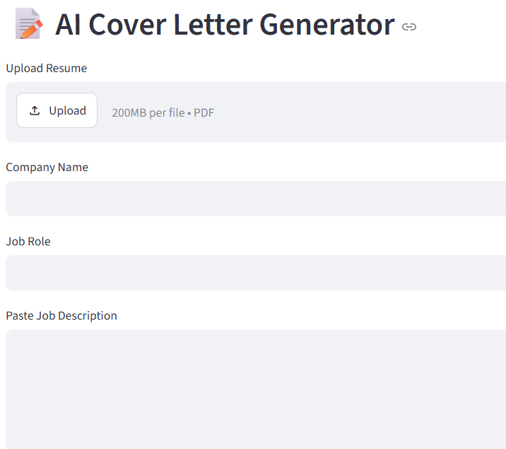

Interview Questions
- What is Multi-Context Prompting?
- Why should AI avoid inventing skills or experience in a cover letter?
- Why separate prompts into different template files?
- How does modular architecture simplify adding new AI features?
- If the generated cover letter is too generic, how would you improve the prompt?

Module 15 – AI Interview Question Generator
This feature will generate interview questions based on the user's resume and target job role, making your project a complete AI Career Assistant.
Goal: Build an AI-powered interview preparation system that:
- Reads the resume.
- Understands the candidate's skills and projects.
- Generates personalized interview questions.
- Provides model answers.
- Assigns difficulty levels.
- Categorizes questions.
Folder Structure
Add these files:
prompts/ interview_prompt.txt
models/ interview_schema.py
utils/ interview_generator.py
Module Architecture
app.py
│
interview_generator.py
│
Prompt Loader
│
Ollama
│
JSON Parser
│
Interview Schema
│
Streamlit UI

Step 1 – Create Prompt
Create:
prompts/interview_prompt.txt
Code:
You are a Senior Technical Interviewer.
Generate interview questions based on the resume and job role.
Resume
{resume}
Job Role
{job_role}
Return ONLY valid JSON in the following format:
{
"technical_questions": [
{
"question": "",
"answer": "",
"difficulty": ""
} ],
"hr_questions": [
{
"question": "",
"answer": "",
"difficulty": ""
} ],
"project_questions": [
{
"question": "",
"answer": "",
"difficulty": ""
} ],
"scenario_questions": [
{
"question": "",
"answer": "",
"difficulty": ""
} ] }
Do not add markdown.
Do not add explanations.
Return only JSON.
Step 2 – Create Schema
Create:
models/interview_schema.py
Code:
from pydantic import BaseModel
class InterviewQuestion(BaseModel):
question: str
answer: str
difficulty: str
class InterviewReport(BaseModel):
technical_questions: list[InterviewQuestion]
hr_questions: list[InterviewQuestion]
project_questions: list[InterviewQuestion]
scenario_questions: list[InterviewQuestion]

Step 3 – Update Validator
Extend response_validator.py:
from models.interview_schema import InterviewReport
def validate_interview_response(data: dict) -> dict:
report = InterviewReport(**data)
return report.model_dump()
Then update json_parser.py:
elif response_type == "interview":
validated = validate_interview_response(data)
Step 4 – Create Interview Generator
Create:
utils/interview_generator.py
Code:
from config.logging_config import setup_logger
from utils.pdf_reader import extract_resume_text
from utils.prompt_loader import load_prompt
from utils.ollama_client import ask_ai
from utils.json_parser import parse_json
logger = setup_logger()
def generate_interview_questions(
pdf_path: str, job_role: str ) -> dict:
logger.info("Generating Interview Questions")
resume = extract_resume_text(pdf_path)
prompt = load_prompt( "interview_prompt.txt" )
final_prompt = prompt.format(
resume=resume, job_role=job_role )
response = ask_ai(final_prompt)
return parse_json( response, response_type="interview" )

Step 5 – Streamlit UI (app.py)
Add a new section:
🎤 AI Interview Question Generator
User inputs:
- Upload Resume
- Job Role
Button:
Generate Interview Questions
Use Streamlit tabs:
tab1, tab2, tab3, tab4 = st.tabs([
"Technical",
"HR",
"Projects",
"Scenario"
])
Inside each tab:
for question in result["technical_questions"]:
with st.expander(question["question"]):
st.write("Answer")
st.write(question["answer"])
st.write(
"Difficulty:",
question["difficulty"]
)
Repeat for the other categories.

Expected UI:
🎤 AI Interview Question Generator
Upload Resume
Job Role
Generate Questions
-------------------------------------------------
Technical
▼ Explain SQL Joins
Answer
Difficulty : Intermediate
---------------------------------------------
▼ Explain DAX
Answer
Difficulty : Advanced
-------------------------------------------------
HR
▼ Tell me about yourself.
Answer
Difficulty : Beginner
-------------------------------------------------
Projects
▼ Explain your Blinkit Dashboard.
Answer
Difficulty : Intermediate
-------------------------------------------------
Scenario
▼ Dashboard performance issue.
Answer
Difficulty : Advanced
Output:

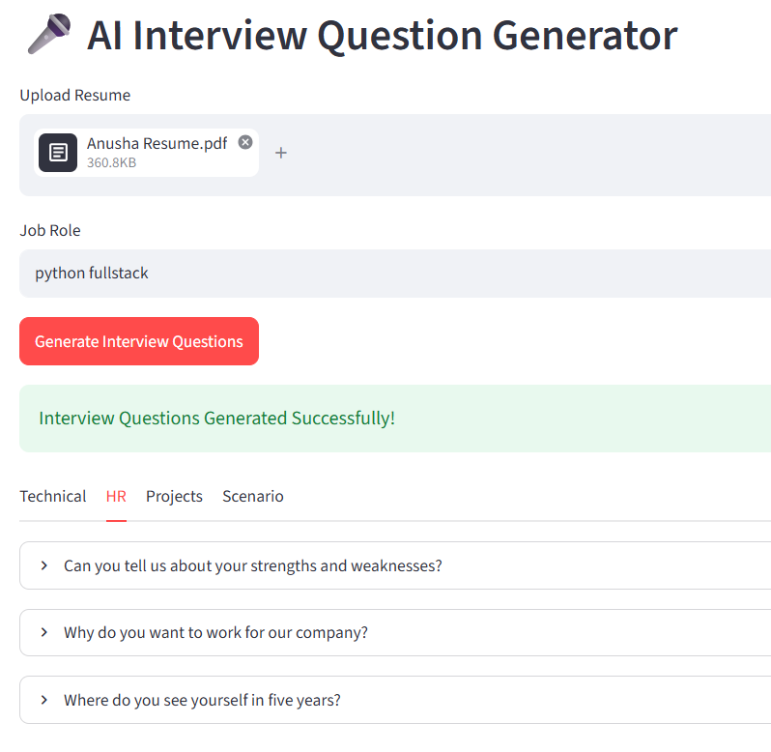

Interview Questions
- Why do we ask the LLM to return JSON instead of plain text?
- Why validate LLM responses with Pydantic?
- What are the advantages of categorizing interview questions?
- Why separate prompts into individual files?
- How does modular architecture make it easier to add new AI features?
Module 16 – AI Learning Roadmap Generator
Goal: Generate a personalized learning roadmap based on:
- Resume
- Target Job Role
The AI will identify:
- Current skills
- Missing skills
- Topics to learn
- Learning order
- Recommended projects
- Interview preparation tips
This feature makes your application much more valuable because it not only analyzes resumes but also guides users on how to improve.

Project Structure
AI-Resume-Optimizer
│
├── prompts
│ roadmap_prompt.txt
│
├── utils
│ roadmap_generator.py
│
├── models
│ roadmap_schema.py
│
├── app.py

Step 1 — Create the Prompt
Create:
prompts/
roadmap_prompt.txt
Code:
You are a Senior Career Mentor and AI Learning Coach.
Analyze the resume and the target job role.
Resume
{resume}
Target Job Role
{job_role}
Return ONLY valid JSON.
{
"current_skills":[ "" ],
"missing_skills":[ "" ],
"learning_plan":[
{
"week":"Week 1",
"topic":"",
"description":"" } ],
"projects":[ "" ],
"interview_tips":[ "" ]
}
Do not explain anything.
Do not use Markdown.
Return ONLY JSON.

Step 2 — Create the Pydantic Schema
Create:
models/
roadmap_schema.py
Code:
from pydantic import BaseModel
class LearningWeek(BaseModel):
week: str
topic: str
description: str
class RoadmapReport(BaseModel):
current_skills: list[str]
missing_skills: list[str]
learning_plan: list[LearningWeek]
projects: list[str]
interview_tips: list[str]

Step 3 — Update response_validator.py
Add:
from models.roadmap_schema import RoadmapReport
Then add:
def validate_roadmap_response(data: dict):
report = RoadmapReport(**data)
return report.model_dump()

Step 4 — Create roadmap_generator.py
Create:
utils/
roadmap_generator.py
Code:
from config.logging_config import setup_logger
from utils.pdf_reader import extract_resume_text
from utils.prompt_loader import load_prompt
from utils.ollama_client import ask_ai
from utils.json_parser import parse_json
logger = setup_logger()
def generate_learning_roadmap(
pdf_path: str,
job_role: str ):
logger.info("Generating Learning Roadmap")
resume = extract_resume_text(pdf_path)
prompt = load_prompt(
"roadmap_prompt.txt" )
final_prompt = prompt.format(
resume=resume,
job_role=job_role )
response = ask_ai(final_prompt)
return parse_json(
response,
response_type="roadmap" )

Output:
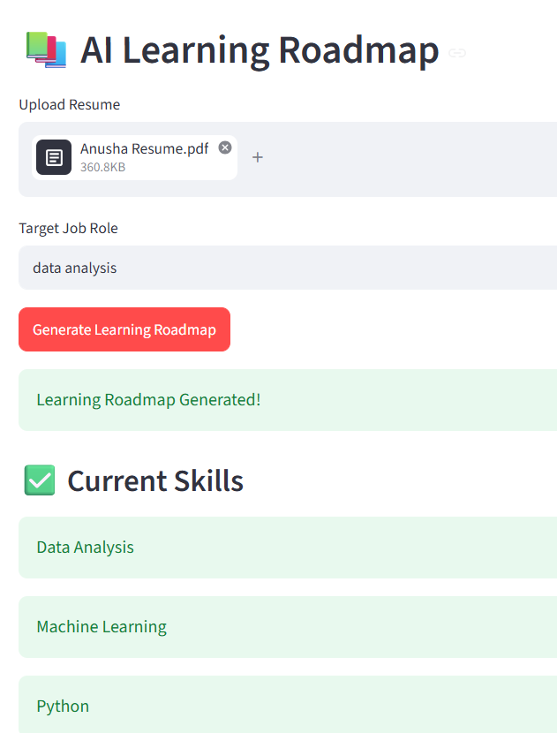

Interview Questions:
  - What is the purpose of the AI Learning Roadmap Generator?
  - How does the Learning Roadmap Generator work from start to finish?
  - Why did you use a Pydantic schema (RoadmapReport) in this module?
  - How does the application generate a personalized learning roadmap?
  - What information does the AI return in the roadmap?
  - What challenges can occur while generating the learning roadmap, and how did you handle them?

Module 17 – Professional UI & Project Deployment
Goal: By the end of this module, your project will include:
- Professional Dashboard UI
- Sidebar Navigation
- Organized Multi-Page Layout
- Progress Indicators
- Downloadable Reports
- Better Error Handling
- Loading Animations
- Session State Management
- Deployment to Streamlit Community Cloud
- GitHub Repository Setup
Part 1 — UI Redesign
Instead of showing every feature on one long page, we'll organize the app into a sidebar menu.
Example:
AI Resume Optimizer
🏠 Home
📄 ATS Resume Analyzer
✍ Resume Rewriter
🎯 JD Matcher
💌 Cover Letter Generator
🎤 Interview Questions
📚 Learning Roadmap
⚙ Settings
ℹ About
This gives a cleaner and more professional experience.
Part 2 — Sidebar Navigation
Replace the long scrolling interface with a menu using:
page = st.sidebar.radio(...)
Each module will appear only when selected.
Benefits:
- Cleaner UI
- Faster rendering
- Easier maintenance
- Better user experience

